Date :11/01/2023 Seat No:

…………………………………………………......

**PRACTICAL NO.3**

**Aim:** Making a Map, Working with Attributes, Importing Spreadsheets or CSV files

Using Plugins, Searching and Downloading OpenStreetMap Data

.

**3A Making a Map**

1. Create a new Thematic Map or open and existing one

Consider the following map as an example map

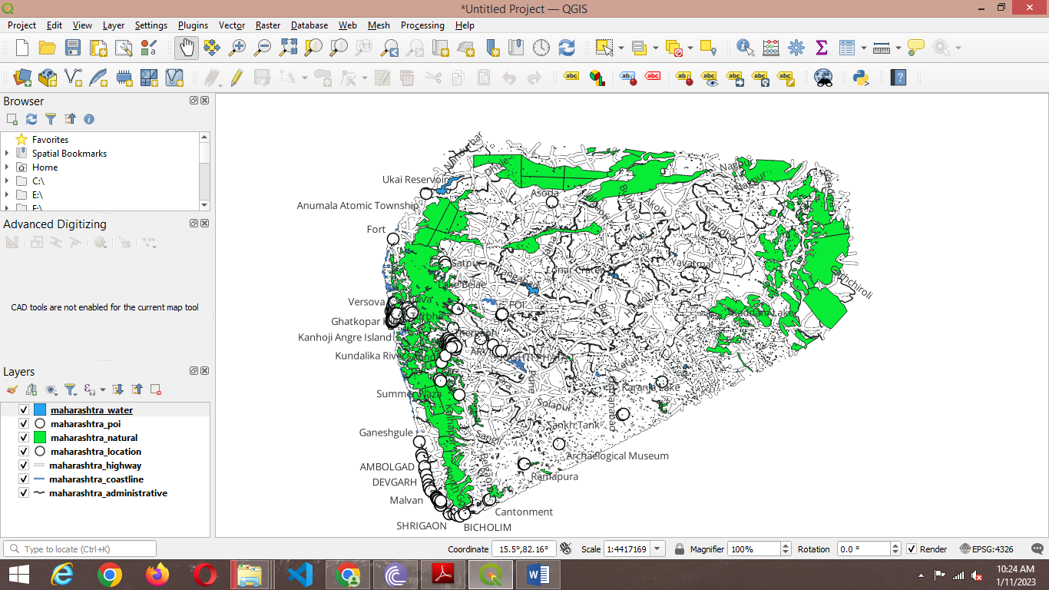

1. Go to Project → New PrintLayout

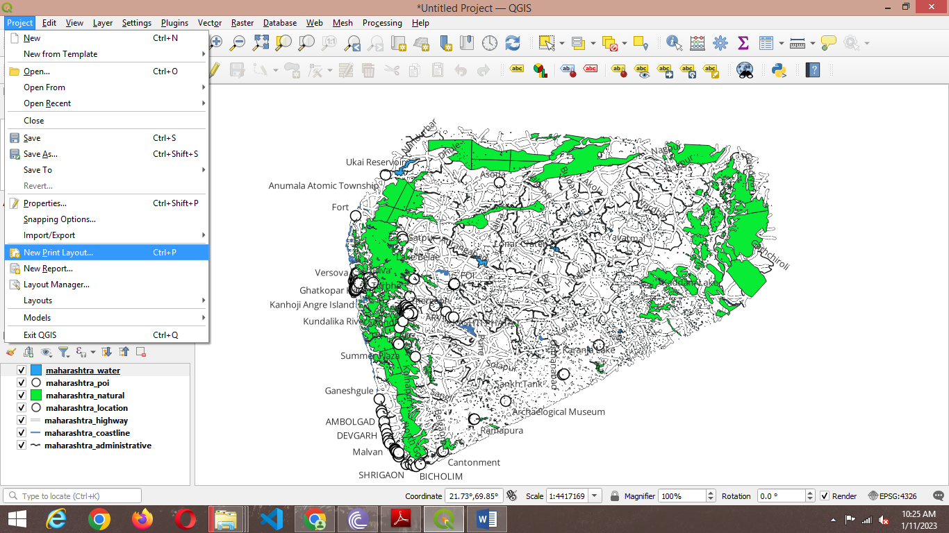

1. Insert a suitable title and press “OK”.

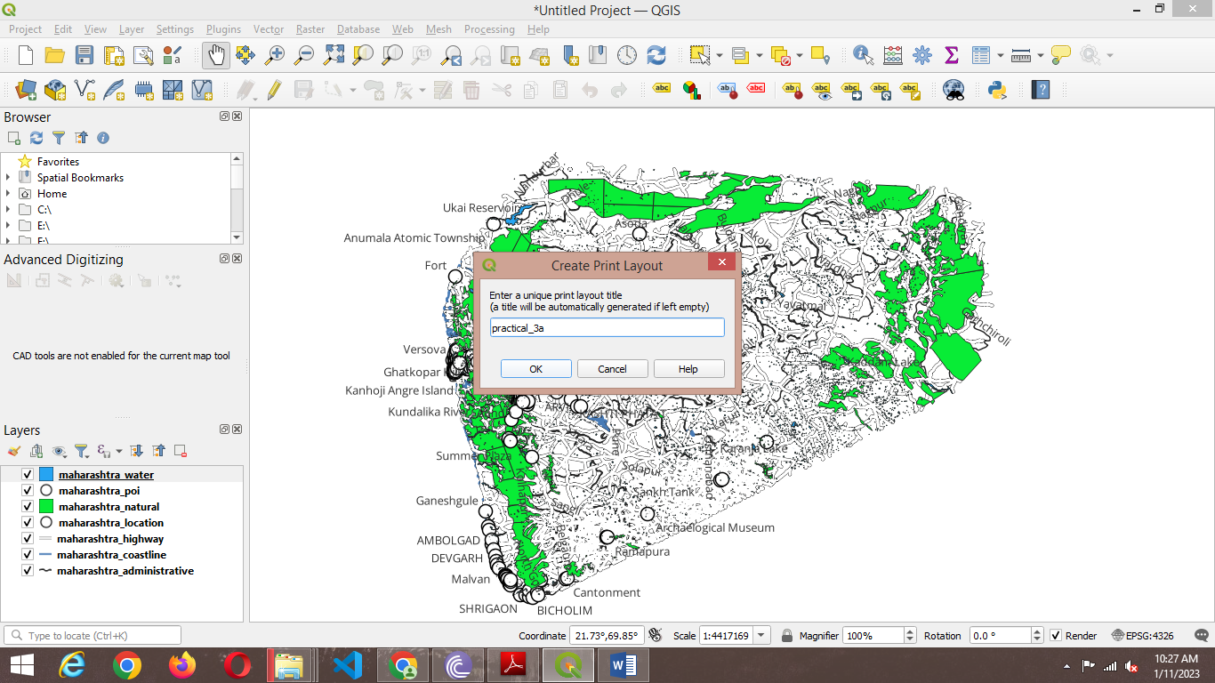

4) A new Print Layout window will open

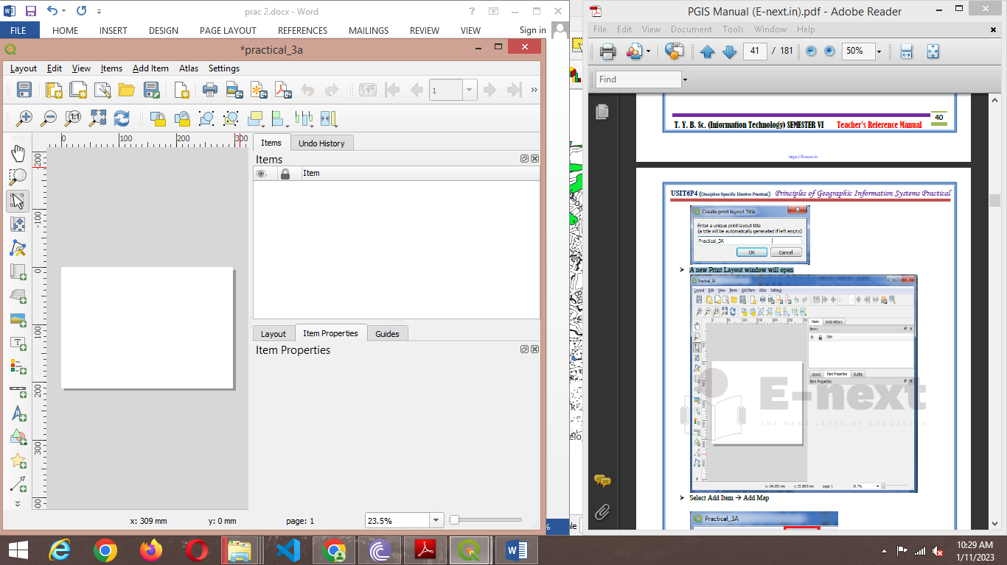

1. Select Add Item → Add Map

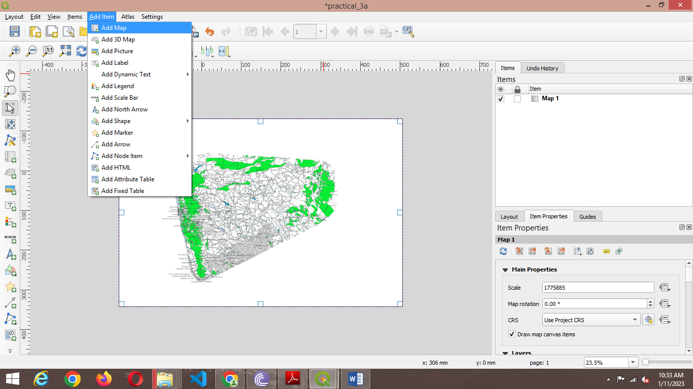

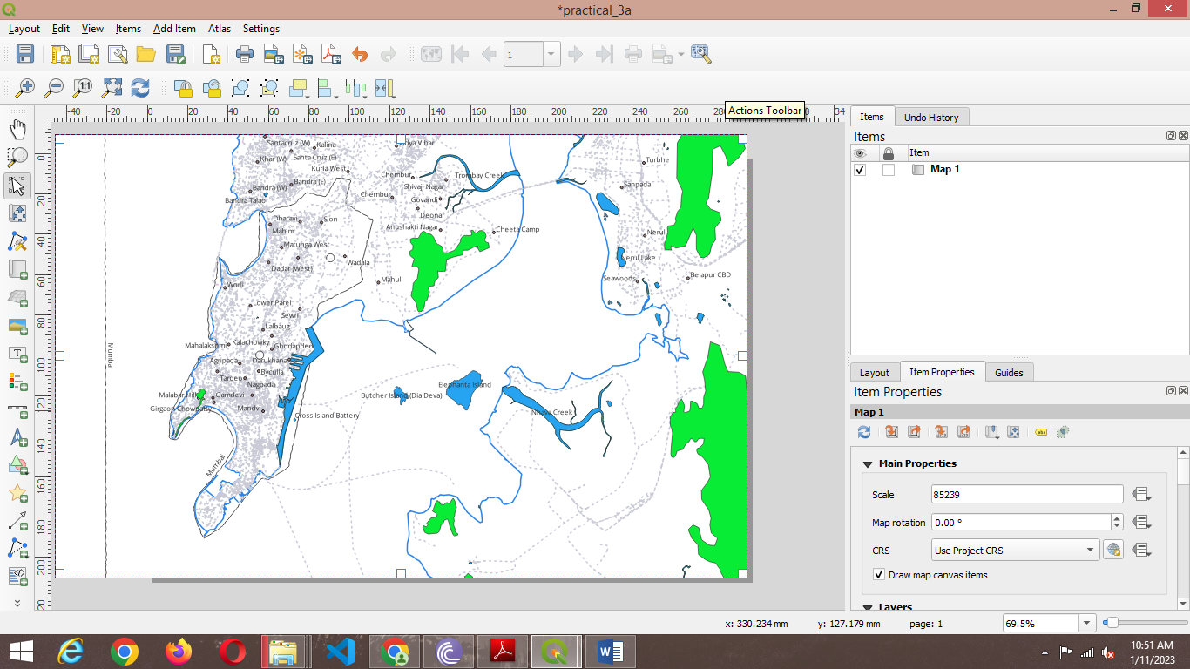

1. fter adding map go to ItemProperties → Map1→ Layers

Check on Lock Layers and Lock Styles for Layers

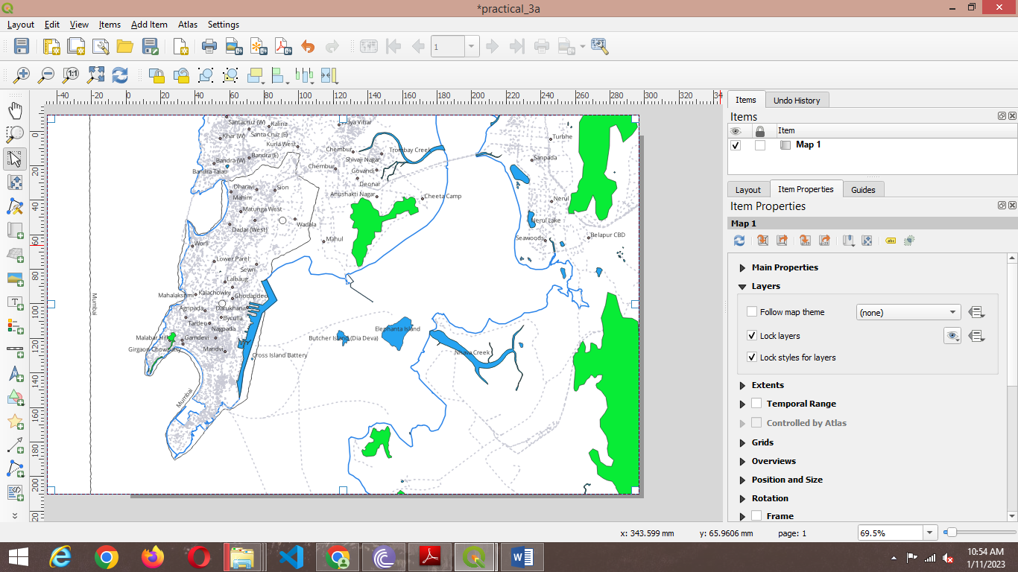

6) Go to Add Item → Add Picture → Place a picture box at appropriate location.

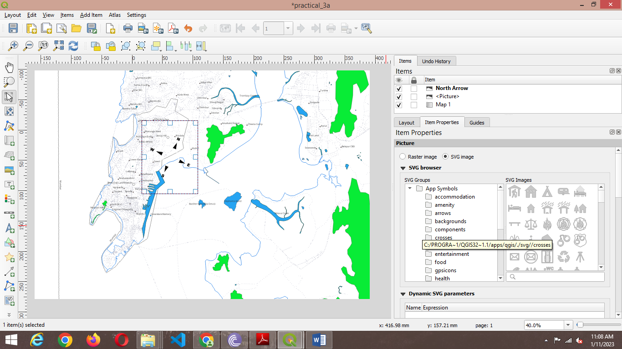

7) Also adjust Image Rotation to its appropriate value.

Item Properties → Image Rotation

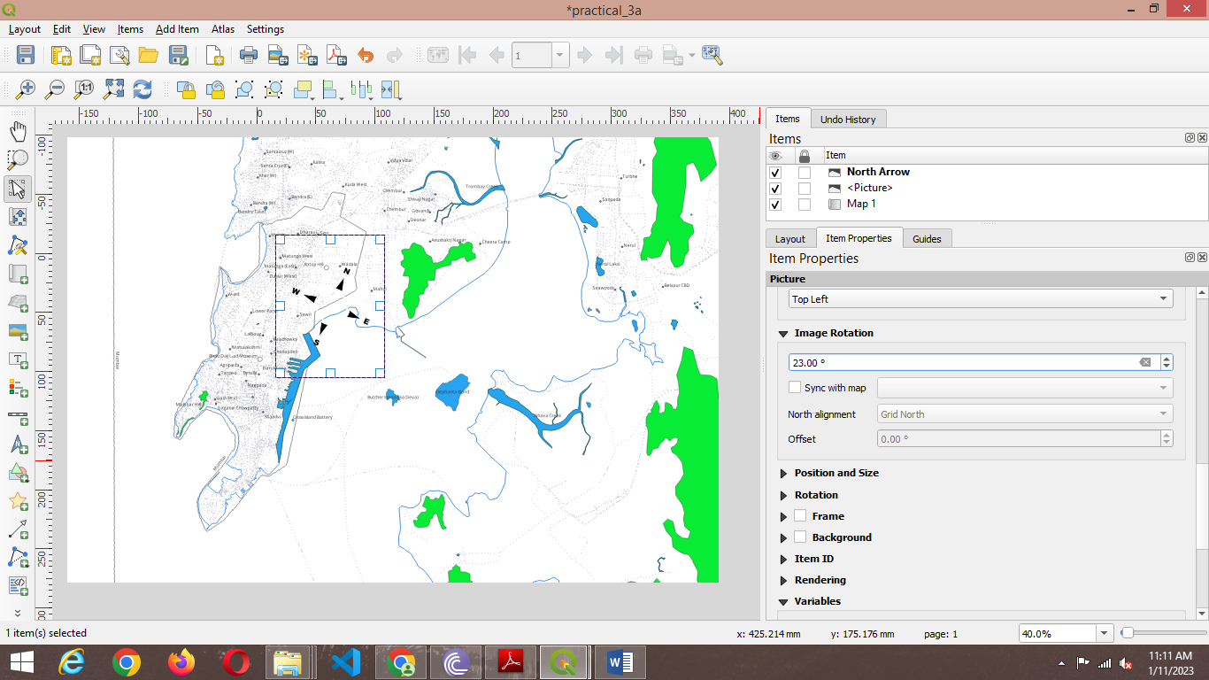

8)Add an inset Using Add Item 🡪Add Picture🡪 Select an area to be highlighted on main Map.

Set a frame for Inset by enabling the check box for Frame.

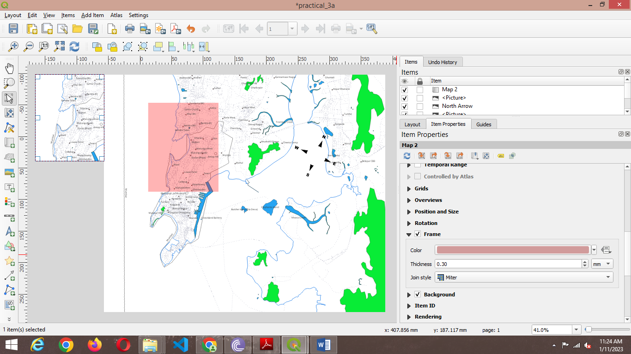

9) The Print Layout will appear like

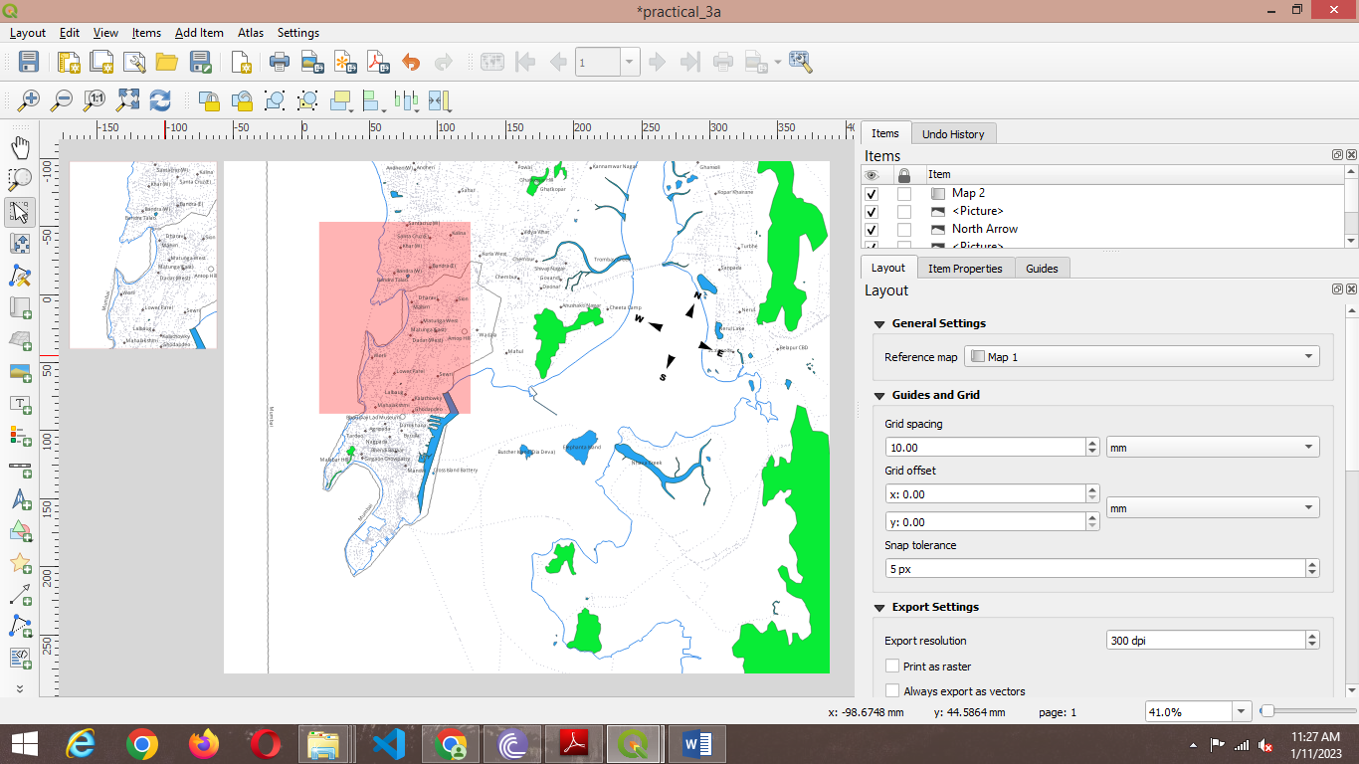

10) Change the Label text To “Mumbai Map”, Set appropriate font size and color using Item Properties→ Main Properties.

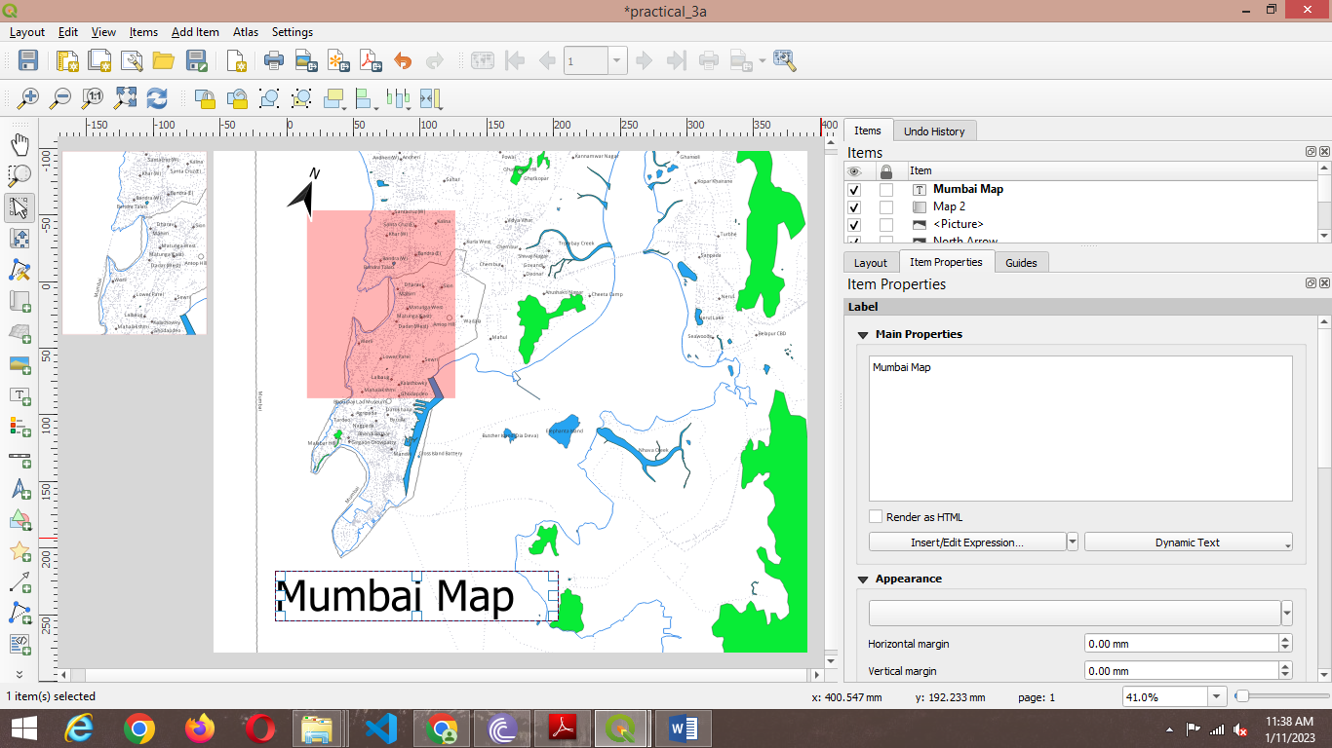

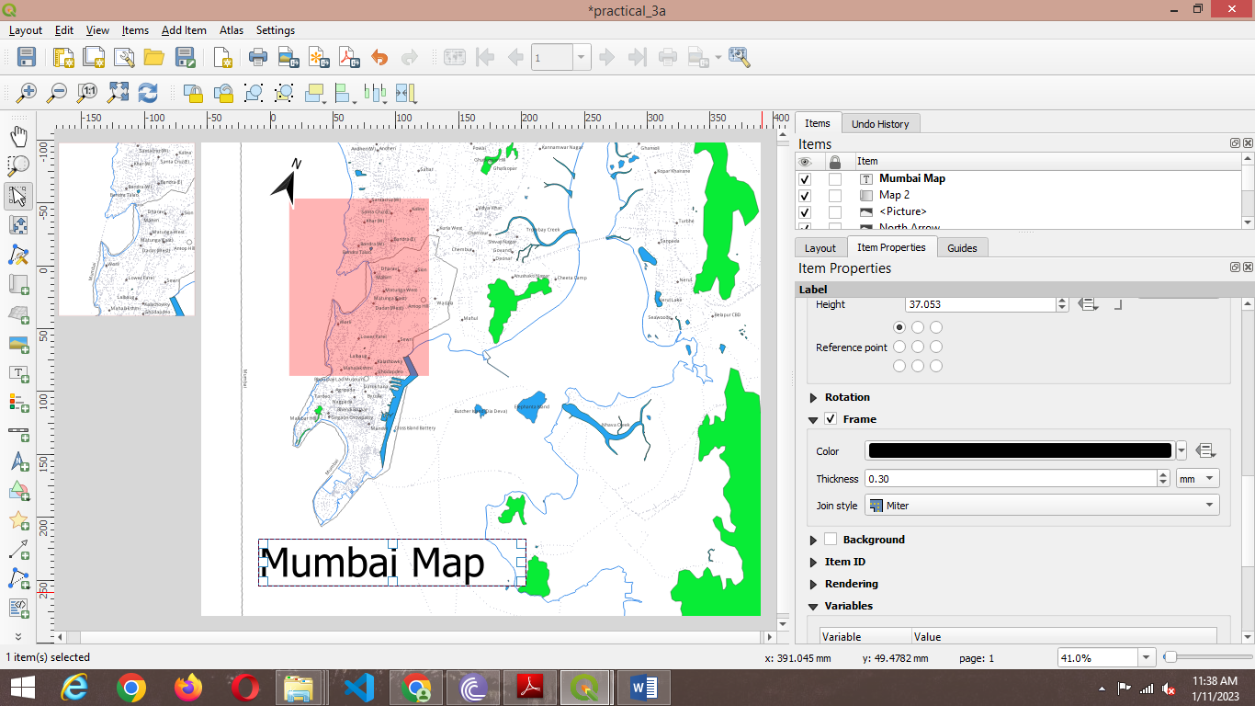

11)Add Item → Add Legend→ Place the legend indicator at appropriate location.

Uncheck auto update and use suitable legend indicator label.

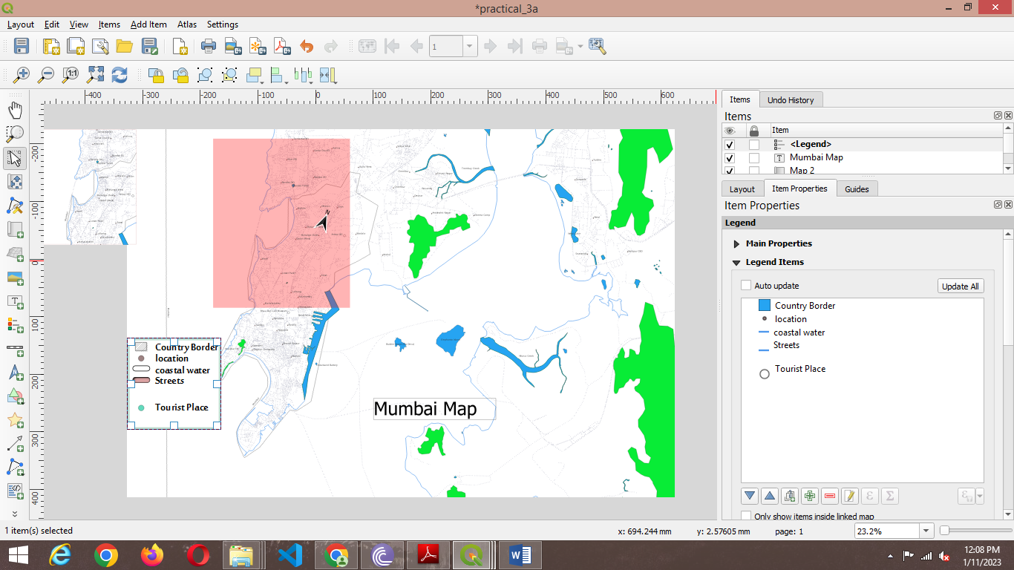

12) The Print Layout will appear

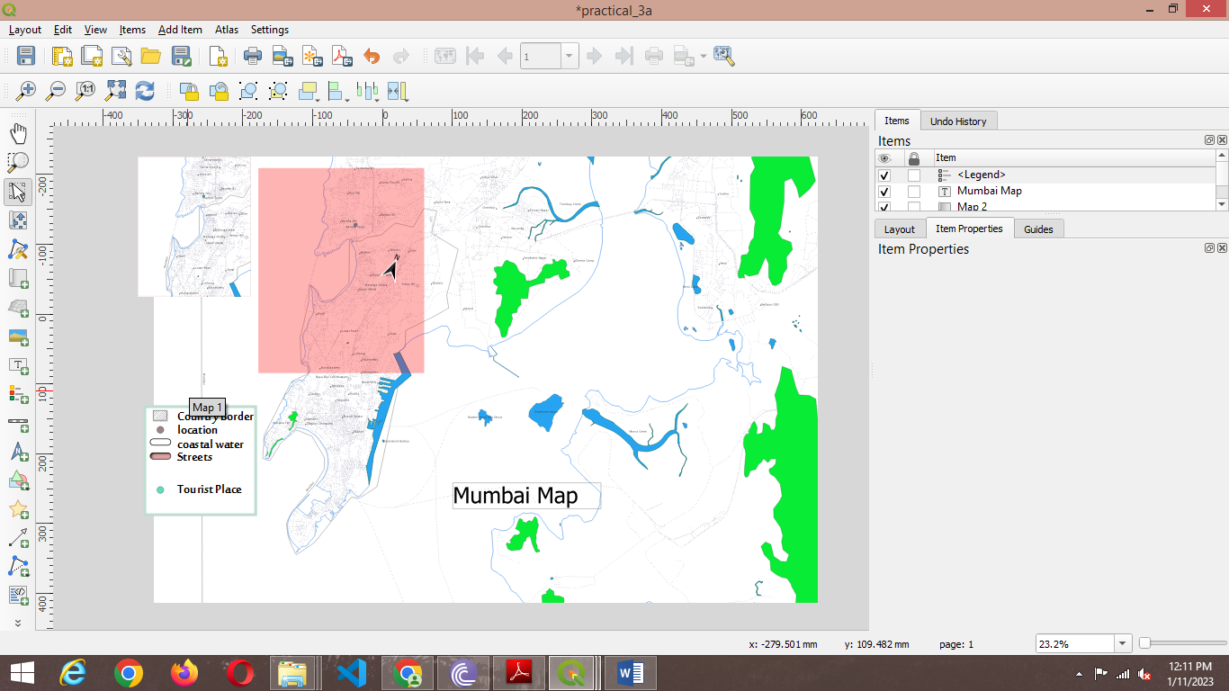

13) Add Item → Add Scale Bar

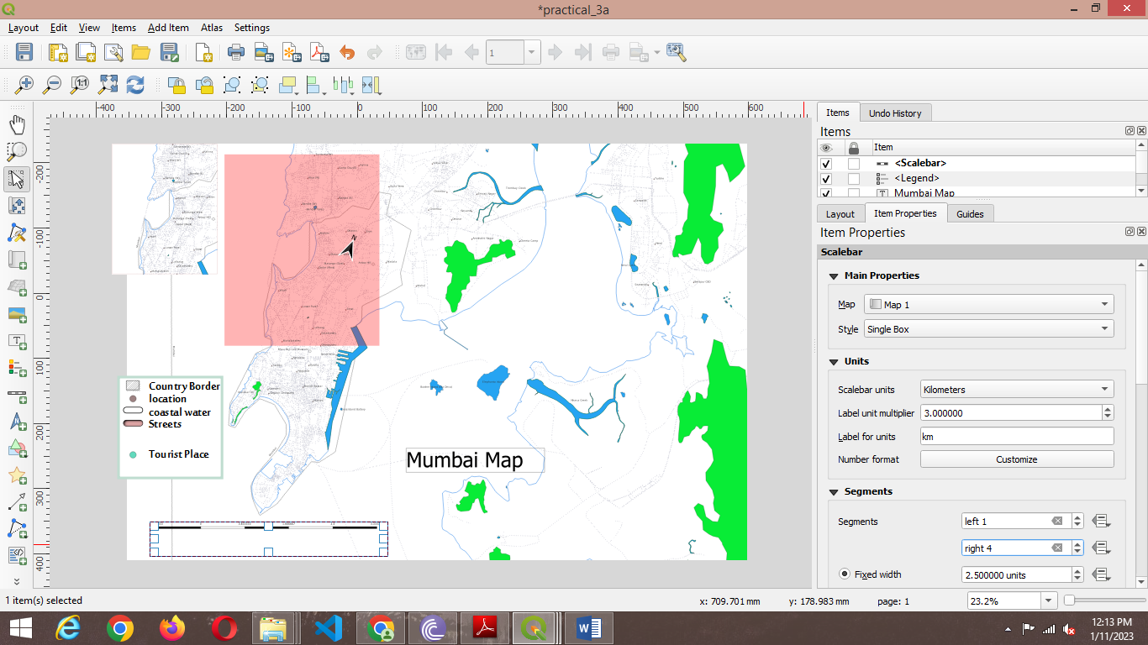

14) Add Item → Add Label→Add a Label using HTML rendering

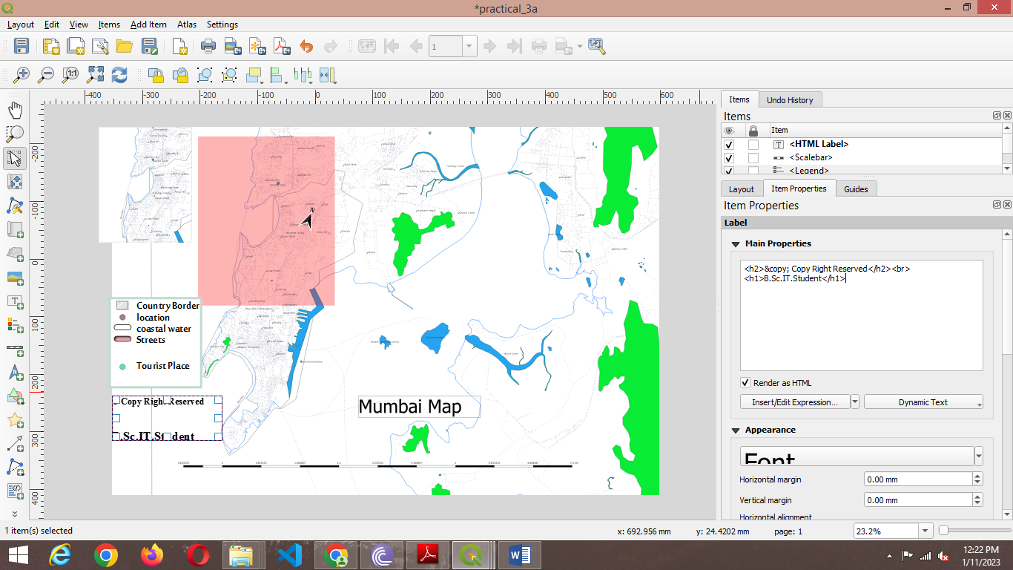

15) A Map can be saved in Image or PDF using Layout → Export as Image / Export as PDF

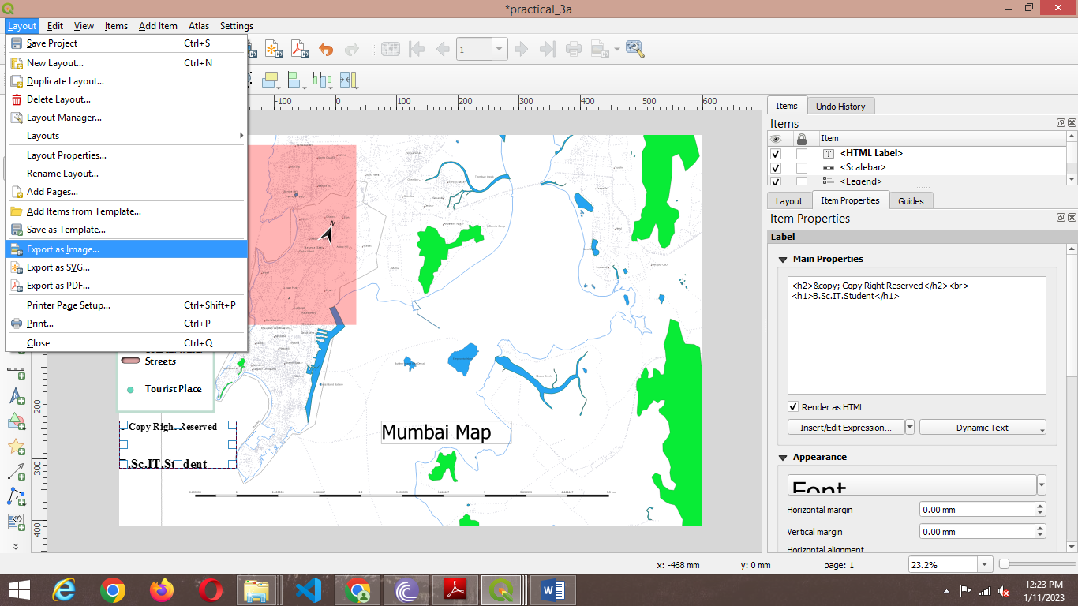

**Output :-**

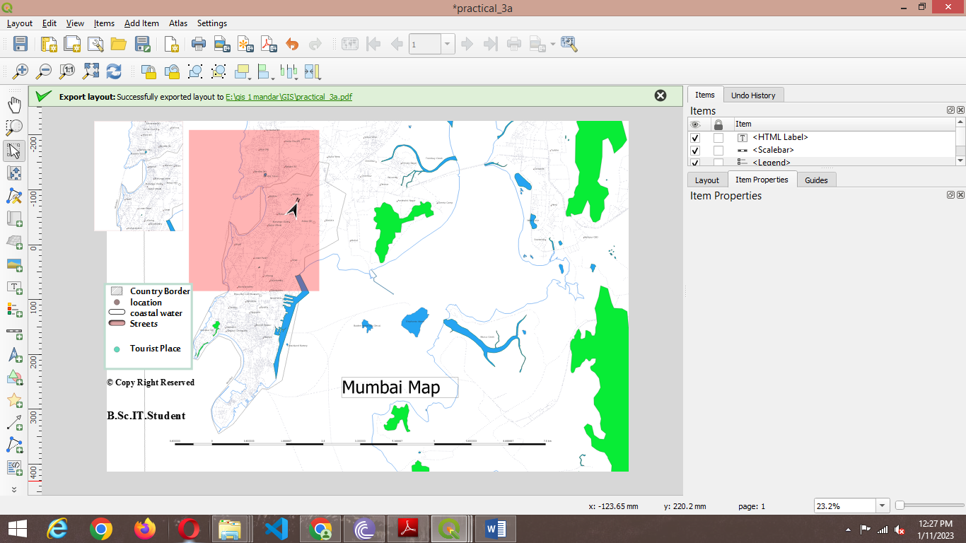

**3B Importing Spreadsheets or CSV files**

1. Go to Layer →Add Layer →Add Delimited text Layer

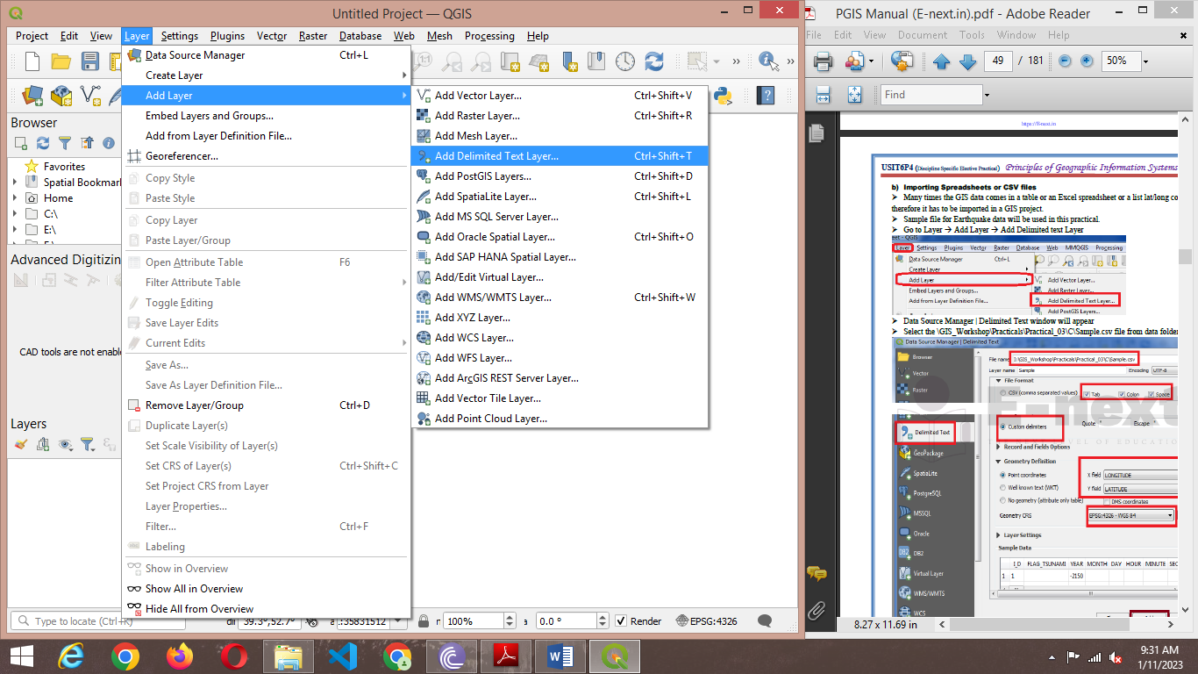

1. Select the \GIS_Workshop\Practicals\Practical_03\C\Sample.csv file from data folder .

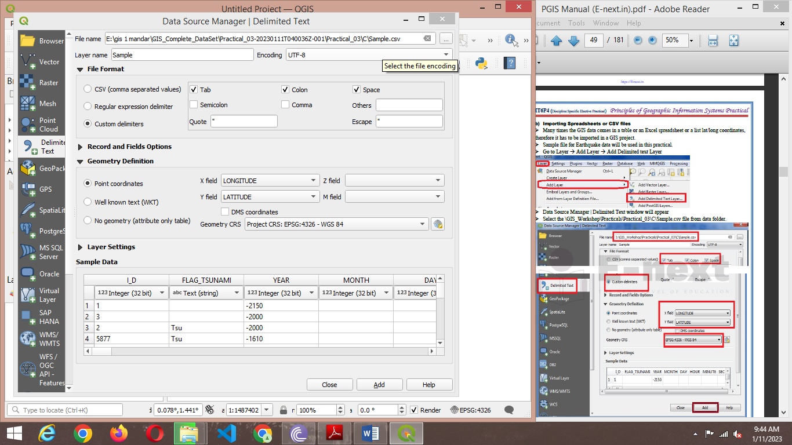

1. Press Add and close the window.

**Output :-**

